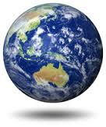

* Currency
* Exchange rate
* Imports/Exports
* Natural Resources
* Type of Economy
* GDP ranking
* Factors of Production
* Economic Strength indicators
* Form of Gov’t
* Election/Voting
* Head of state
* Capital
* Elections
* Who votes
* Limited or Unlimited Government
* Rule by one, a small group, or the people?
* Purposes of government
* Origin of country
* Major battles
* Major events
* Famous people
* Timeline
* Primary/Secondary Sources
* Absolute Location
* Relative Location
* Size (sq mi & rank)
* Population (# and rank)
* Major landforms
* Climate (temp & rainfall)
* 5 themes of Geography

Economics

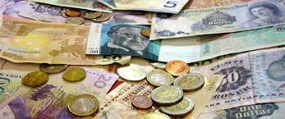

History

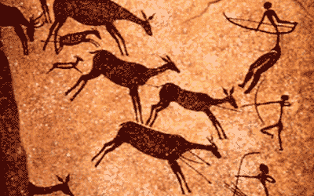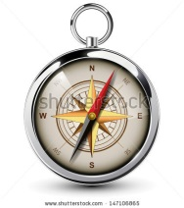

Geography

Culture

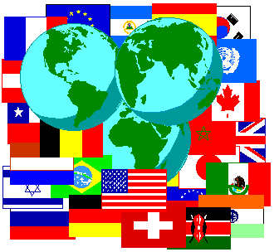

Government

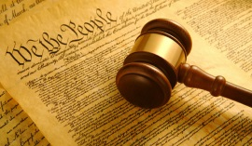

* Life expectancy
* Literacy
* Languages
* Religions
* Education
* Dress
* Holidays
* Traditional food
* Music/instruments